**Exercise ExtractDigits (Loop)**: Write a program called **ExtractDigits** to extract each digit from an int, in the reverse order. For example, if the int is 15423, the output shall be "3 2 4 5 1", with a space separating the digits.

**Hints**: Use n % 10 to extract the least-significant digit; and n = n / 10 to discard the least-significant digit.

Write a program called KeyboardScanner to prompt user for an int, a double, and a String. The output shall look like (the inputs are shown in bold):

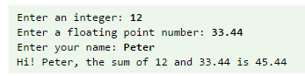

CollegeAdmit program that use a Scanner

|  |  |
| --- | --- |
|  | * to read user input for a student's grade point average and SAT exam score, |
|  | * and uses these values to decide whether the student is admitted to the |
|  | * university. A GPA below 1.8 will cause the student to be rejected; an SAT |
|  | * score below 900 will also cause a rejection. Otherwise the student is |
|  | * accepted. If both the GPA and the SAT score are too low, print the message |
|  | * about the GPA being too low. |
|  | */ |
|  |  |
|  |  |